**Assignment Title: The social impact to Saibai island food system by climate change**

**Student name: Shen Hu**

**Student number: 254275075**

**Tutorial Class: Thursday 6-9pm**

**Project Opportunity: Climate Change-Food System-Social Impact**

**5.4 Climate-adaptive food systems**

Food is an important problem that should be considered in modern Saibai island. A climate-adaptive food system is quite needed for local people, because they need more stable and cheaper food supply, and also help them to reduce pressure of society and culture that given by climate change.

**Introduction**

Saibai Island is a long and narrow east-west island located on the north side of the Torres Strait, about 150 kilometers from Australia and about 4 kilometers from Papua New Guinea. This island is low-lying and around 108 square kilometers. The people of the island live in a small coastal community by the sea. This small community now faces various challenges from climate change, including extreme weather, food supply challenge and other pressures.. This report explores how Saibai island food system is threatened. Through figuring out threats on the island, troubles of helping island can be found.

**Extreme weather and Climate Change on Saibai Island**

Climate change has caused serious impact on community. Generally, Saibai people face two main troubles, raising sea level and flood.

Firstly, in a report from Torres Strait regional authority(TSRA, 2011), the sea level around Saibai Island rose by an average of 6 mm a year between 1993 and 2010, which is twice of global data. The sinking of island is happening.

Next, flood is another major challenge that islanders have to face. Flood includes waves, tides and rainfall’s flood. In the report(TSRA, 2011), the risk of flooding caused by increasing rainfall was mentioned. In addition, tides brought by hurricanes and the king tide flood many areas of the island every year, especially the islander's community, which highest point is only 1.7 meters(EWB Challenge 2025). Even though local people built a sea wall to protect the community, it has already destroyed by waves(Wellauer & Ruddick, 2024) before. This is a significant risk for islanders’ safety.

**Troubles for local society**

Above two environmental challenges are significantly impacting the society of the islanders.

Firstly, Uncle Paul Kabai(Wellauer & Ruddick, 2024) is one of resident of the island. He showed negative impact that has already happened on the island and terrible results. In the past, people could play on the beach, grew some food and fruit, or followed their local culture to bury umbilical cords as gifts for new babies(Wellauer & Ruddick, 2024). However, right now the beaches are flooded, the farmlands are destroyed, and the mangroves are covered by sea water. People's activity space is compressed, and for the foreseeable future, sea level will continue to erode the land on the island.

Secondly, raised sea level and floods threats local agriculture. Agriculture is an important part for local society. It not only provides food, but also be a profound cultural ties of the local people(EWB Challenge 2025). Nevertheless, waves and tides bring salty water on land(Huusko, 2015). Seawater will leave salt after evaporation on land, which will lead to an increase in soil salt under long-term influence, which is not conducive to crop growth. Although rainwater can release salt percentage of land, drying may happened. During the wet season, Saibai island can get 95 percent rainwater of a year(EWB Challenge 2025). On the contrary, this means rest half year is quite dry, thus agriculture will be threatened. Besides, water is influenced because of same reason. An example is that in 1947, part of island people moved to mainland because of extreme weather(Huusko, 2015). At that time, a water spout attacked the community. Drinking water was polluted. Some people express concern should this situation recur.

Finally, food supply should be mentioned. Saibai island is far from any large city, which means import food is expensive. Especially recent years(AIATSIS, 2016). In 2015, a project was located the island, which called Saibai Mekem Garden community project(AIATSIS, 2016). This project is a 1 ha size farm, which is used to grow food based on islanders’ traditional agricultural culture. It allows local people to get some fresh and cheaper food. At the same time, the rely of import food can be reduced. All these benefits can help people to lose some pressure. However, this farm is threatened by wild animals, complex and undeveloped land, and few people still practice traditional gardening skills(AIATSIS, 2016). Without solving these issues, the well-beings of the islanders cannot be maintained.

**Conclusion**

Saibai island food system confronts multiple challenges. Including extreme weather, climate change and unstable food supply. All these factors pose significant risks. By this report, all these issues need solutions urgently.

**References**

Australian Institute of Aboriginal and Torres Strait Islander. (AIATSIS, 2016). Saibai Mekem gardening project: developing long term sustainability and wellbeing of Saibai community. <https://aiatsis.gov.au/publication/116805>

Engineers Without Borders (2025). Introduction to Saibai Island. <https://ewbchallenge.org/challenge/saibai-island-tsirc/introduction-to-saibai-island/>

Engineers Without Borders (2025). Design Area 5 – Climate Change Adaptation. <https://ewbchallenge.org/challenge/saibai-island-tsirc/design-area-5-climate-change-adaptation/>

Huusko, S. (2015). 'We're sinking here': climate change laps at front door of Torres Strait Islands. The Guardian. <https://www.theguardian.com/australia-news/2015/dec/08/were-sinking-here-climate-change-laps-at-front-door-of-torres-strait-islands>

Torres Strait Regional Authority. (TSRA, 2011). OBSERVED AND FUTURE CLIMATES OF THE

TORRES STRAIT REGION. <https://www.tsra.gov.au/document/observed-and-future-climates-of-the-torres-strait-region-2011/>

Wellauer, K., & Ruddick, B. (2024). Islanders determined to keep hope, culture alive as Torres Strait rises. ABC News. <https://www.abc.net.au/news/2024-12-15/rising-ocean-threat-to-island-culture-torres-strait-australia/104613496>

**Appendix: Sources**

Australian Institute of Aboriginal and Torres Strait Islander.

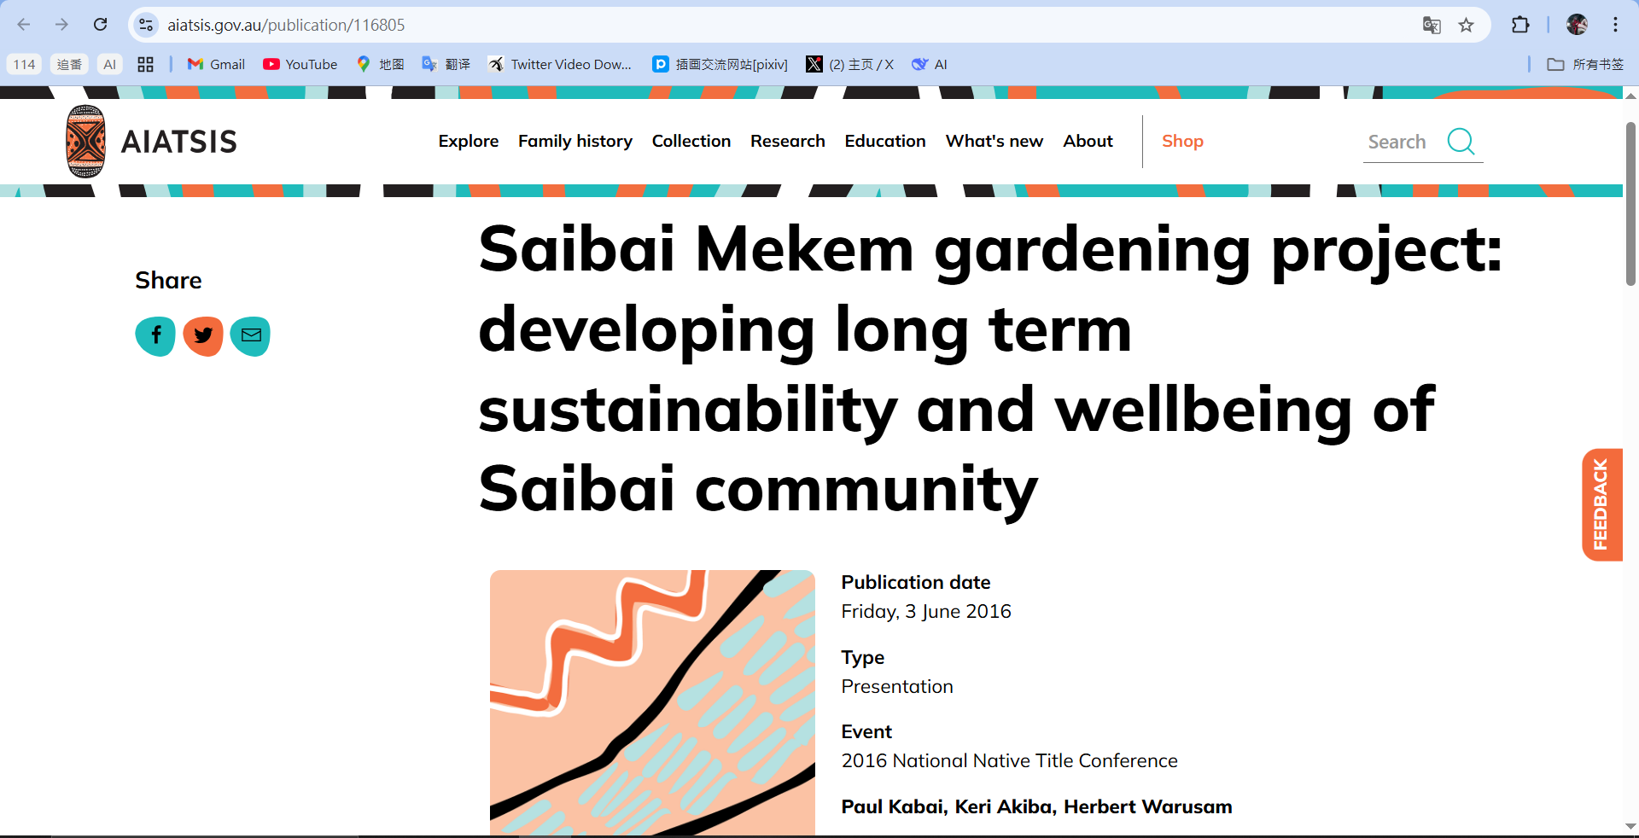

EWB Challenge-Introduction to Saibai Island

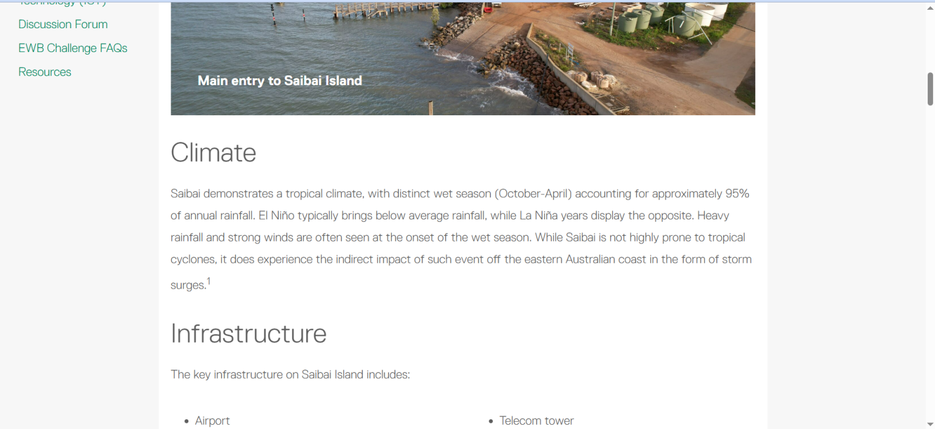

EWB Challenge-Design Area 5-Climate Change Adaptation

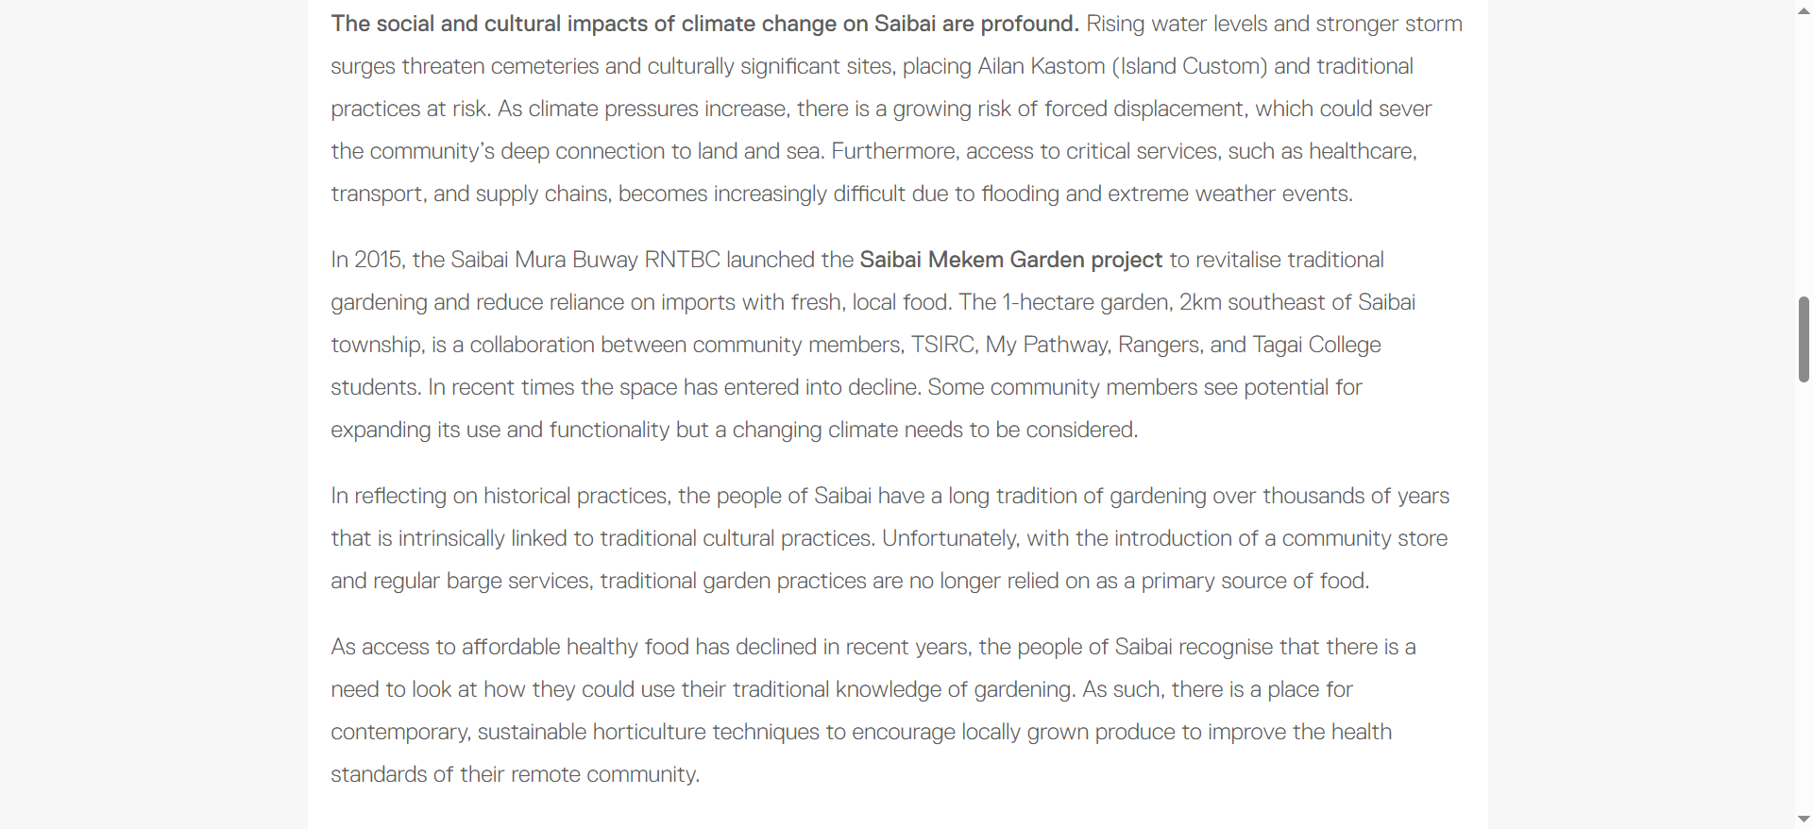

The Guardian

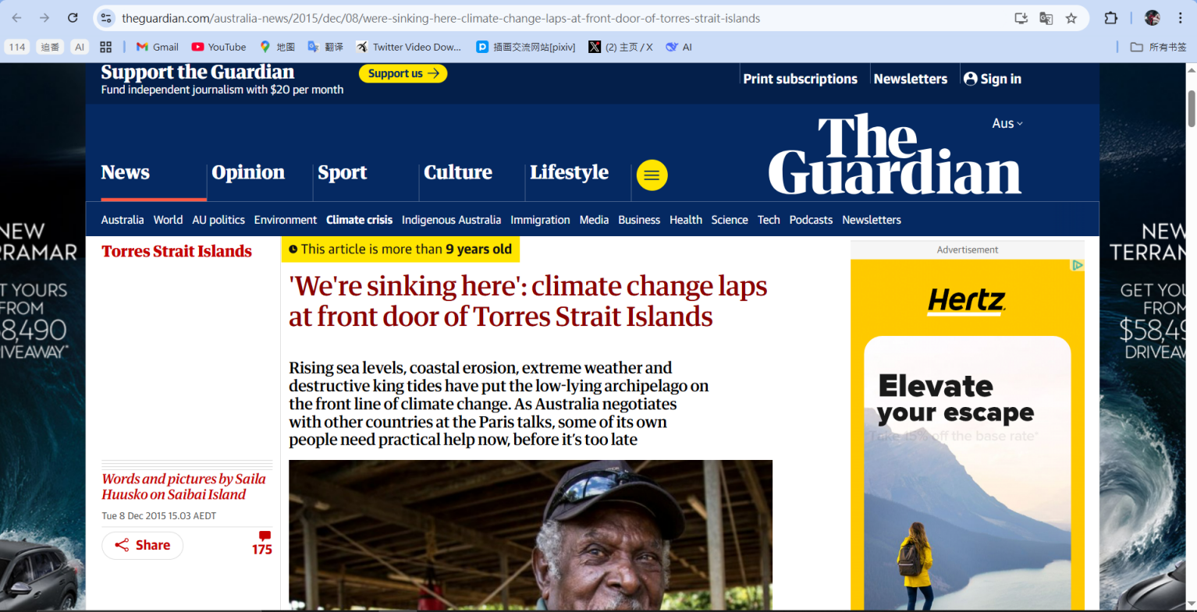

Torres Strait Regional Authority

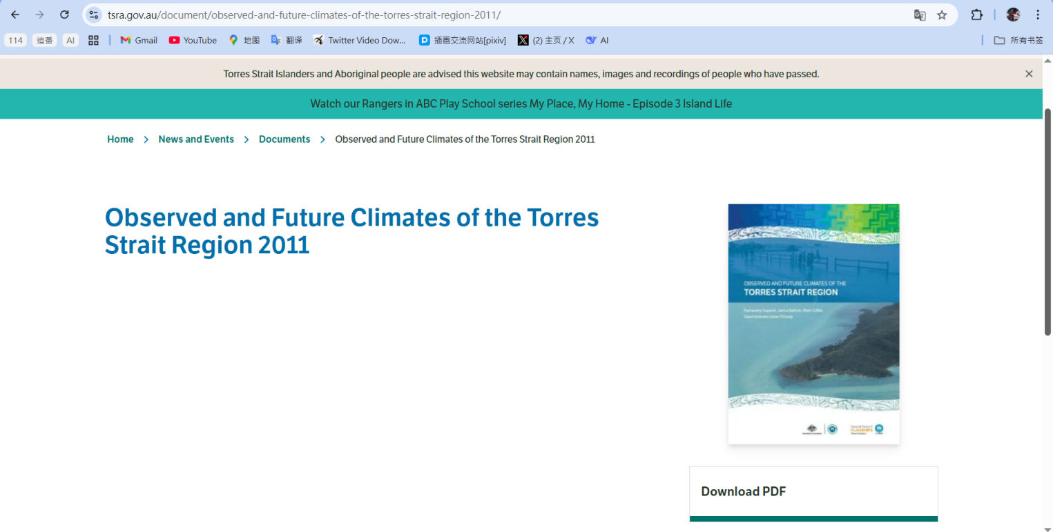

ABC News

